ECM3432DA Software Engineering 1

Agile Development Exercise

Student ID: 730087020

Word Count
Section | Count
1. Introduction | 532
2. KSB Progress Table | 2064
3. Reflective Analysis | 2653
Total | 5249

Word Count 0
1. Project Overview 1
1.1. Outline 1
1.2. Objectives 1
2. Artifacts 2
2.1. Statement of Requirements 2
Functional 2
Non-Functional 4
2.2. Software Architecture 5
Client-Server Pattern 5
Server Architecture Design 5
Client Architecture Design 5
2.3. Client UI Design 6
2.4. Software Release 7
3. Process 9
Requirements Engineering 9
Review of Software Assets 11
Appendix 13

1. Project Overview

1.1. Outline
This project proposes a new social platform, Community Tourist Assistant.
Community Tourist Assistant will allow visitors to the region to identify interesting places and activities.
Information on the platform will be crowd sourced by locals and tourists alike.

The proposal is formed of the following:
- Statement of requirements that must be met by the solution
- Software architecture recommendation
- Software User Interface (UI) design
- Minimum Viable Product (MVP) prototype

1.2. Objectives
- Centralise tourist information.
- Reduce the overhead for stakeholders of local tourism.
- Encourage profitable tourism through community engagement, such as ratings.
- Increase the length of time visitors stay, by presenting a wide range of sites and activities.
- Publicise niche and ever-changing tourist attractions in a scalable manner.

2. Artifacts

2.1. Statement of Requirements

Functional
Epic | User Story | Delivered
Scrollable ‘Places’ page | As a Tourist I want to see a list of local places so that I can identify somewhere to visit.
Scrollable ‘Places’ page | As a Tourist I want to see cover photos of places so that I can visualise list items.
Scrollable ‘Places’ page | As a Tourist I want to see a place's star rating out of 5 so that I can compare it to other options.
Scrollable ‘Places’ page | As a Tourist/Local I want to search the place list so that I can find details for a specific place.
'Place' details page | As a Tourist I want to open a place list item so that I can see more details.
'Place' details page | As a Tourist I want to see more photos when selecting a place so that I know what to expect.
'Place' details page | As a Tourist/Local I want to upload photos so that I can contribute to a place's details.
'Place' details page | As a Tourist I want to leave a star rating out of 5 so that I can raise the profile of a place.
'Place' details page | As a Local I want to report incorrect place details so that they are flagged to an administrator.
'Place' details page | As a Local I want to report unrelated place photos so that they are flagged to an administrator.
‘Sign Up or Log In’ page | As a Tourist/Local I want to create an account of type Tourist/Local so that I can contribute to the platform.
‘Sign Up or Log In’ page | As a Tourist/Local I want to log in so that I can contribute using my existing account.
‘Sign Up or Log In’ page | As a Tourist/Local I want to log out so that I can use a different account.
‘My Badges’ page | As a Tourist/Local I want to see a list of my badges so that I know my contributions are worthwhile.
‘Upload’ page | As a Local I want to upload new places so that I can contribute to the platform.
‘Manage Accounts’ admin page | As an Administrator I want to see a list of users, including account status, date joined, contributions and badges, so that I can manage user accounts.
‘Manage Accounts’ admin page | As an Administrator I want to disable user accounts so that non-compliant users cannot contribute.
‘Manage Accounts’ admin page | As an Administrator I want to assign badges so that users are incentivised to contribute.
‘Manage Places’ admin page | As an Administrator I want to see a list of reported photos and place details so that I can take action or dismiss them.
‘Manage Places’ admin page | As an Administrator I want to edit reported place details so that I can correct them.
‘Manage Places’ admin page | As an Administrator I want to remove photos so that I can address user reporting.

Non-Functional
Category | Sub-Category | Requirement
Product | Performance | The application must support at least 100 users simultaneously, with <2s latency.
Product | Reliability | Errors must be logged, and displayed if relevant, instead of disrupting service.
Product | Security | Personal information must not be accessible by other users, even administrators.
Product | Usability | Navigation between pages must be smooth and align with normal browser behaviour.
Organisational | Operational | The application must run on any device with a modern browser and Internet connection.
Organisational | Development | The codebase must be tested and committed to version control.
External | Regulatory | The storing of user data must be compliant with the Data Protection Act 2018 and GDPR.
External | Ethical | Administrators must have the ability to resolve reports of inappropriate place details or photos promptly.

2.2. Software Architecture

Client-Server Pattern

Server Architecture Design

Client Architecture Design

2.3. Client UI Design

2.4. Software Release

3. Process

3.1. Requirements Engineering
January 16



User Personas


Tourist
Goals
- To identify interesting places and activities by viewing place details, photos and ratings
- To contribute ratings and photos
- To collect badges
Local
Goals
- To contribute place photos
- To report incorrect place details
- To report unrelated photos
Administrator
Goals
- To manage user accounts
- To manage and act upon reported place details and photos
- To encourage contribution, such as by assigning badges

Epics
- Scrollable ‘Places’ page
- ‘Place’ details page
- ‘Sign Up or Log In’ page
- ‘Upload’ page
- ‘My Badges’ page
- ‘Manage Accounts’ admin page
- ‘Manage Places’ admin page

January 23
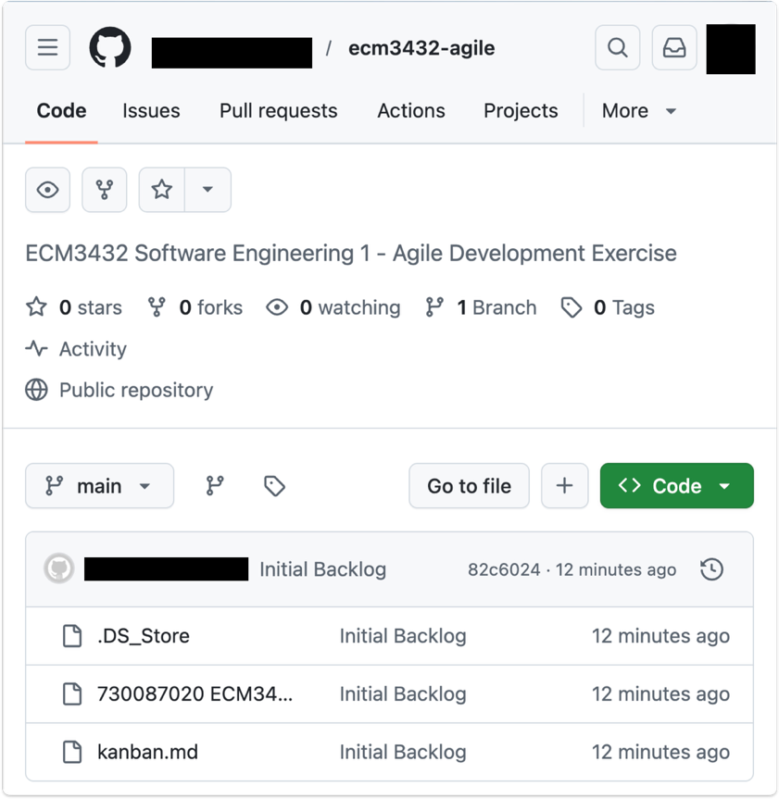
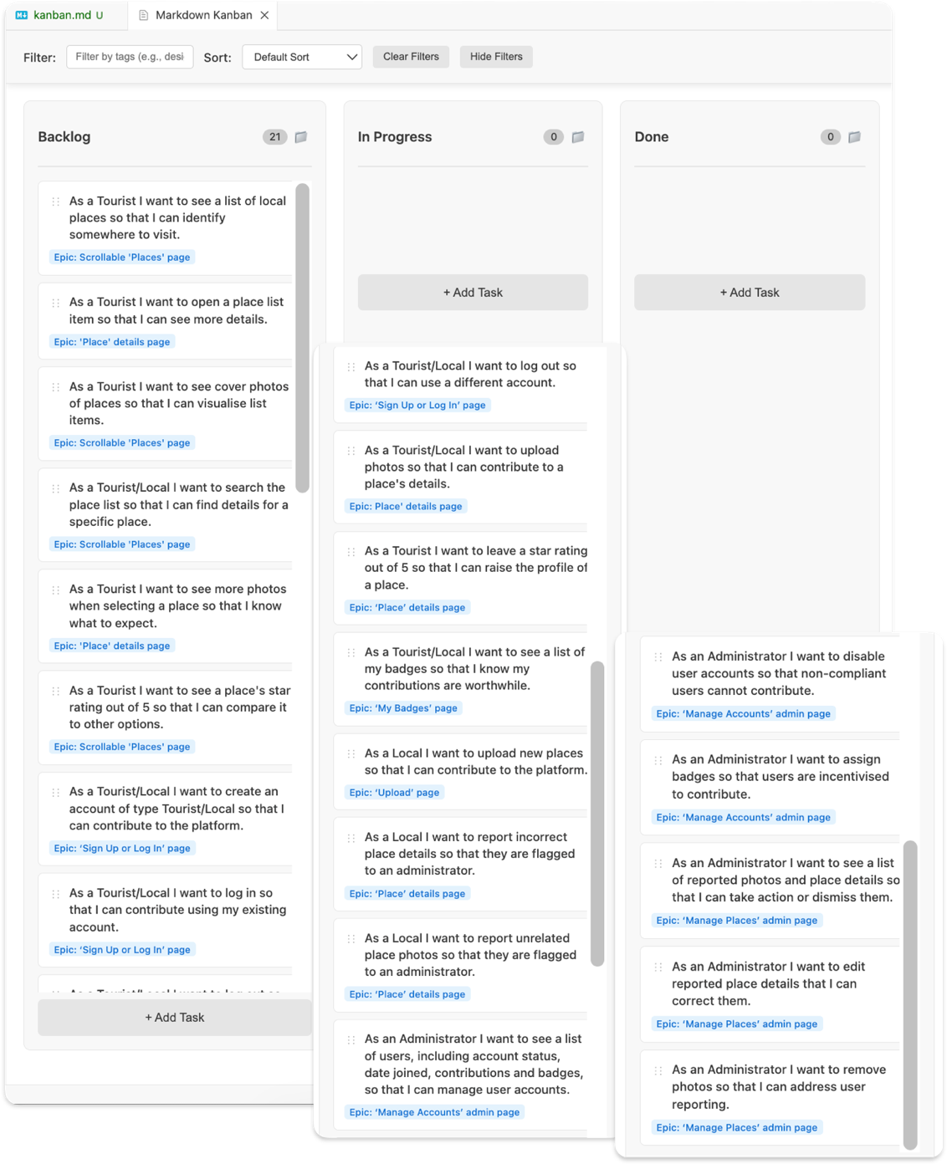
Initial Backlog (+ non-functional – added to Statement of Requirements)

3.2. Review of Software Assets
January 26
Version Control
Git: I recommend git, the industry-standard free and open-source distributed version control system (Git, 2026).
Github: For online hosting of the git repository, I recommend Github. While there are popular alternatives, including Bitbucket, Github is preferred for small, public codebases (Tunggal, 2026)

Agile Project Management Tools
Scrumban: I recommend a hybrid ‘Scrumban’ approach. The two most popular frameworks, Scrum and Kanban, offer different advantages. While Kanban would typically be favoured for a small (single-person) project like this, the short timeframe demands regular checkpoints to ensure all features are delivered. A hybrid approach, as recommended in the literature (Ozkan, et al., 2022), will pair the Sprint structure of Scrum with the backlog visualisation of Kanban, without requiring a dedicated Scrum Master to carry out prioritisation or analytics.
Markdown Kanban: To minimise the number of working environments, I suggest a light-weight Kanban board that is integrated with the code editor, over a stand-alone service like Jira or Trello. The open-source VS Code extension Markdown Kanban serves this purpose well. Changes can be committed to version control and the board can be viewed alongside development without context switching (Github, 2025).

Design Tool
Draw.io: Diagramming tools are available at varying levels of professionalism and complexity. Figma is industry-level and conveys realistic user interface designs but carries a big overhead for an MVP. Lucidchart fits a similar niche for diagramming. Draw.io is a simple but versatile tool that will allow all of the UI designs and architecture diagrams to be created quickly within VS Code and committed to version control.

Application Stack – Client Interface, Server API, Database and Testing
Go & React: If Python is the preferred language, a FastAPI backend and NiceGUI frontend present a convenient open-source option. Alternatively, given the client-server architecture, separate languages could be used for the server and client. Go, used by my current team at work, parallels FastAPI in speed and has both server and testing capabilities built into the language. Meanwhile, a JavaScript framework like React, also used by my team, could be used for a web interface. Go’s minimal server setup makes it a good choice for this MVP. Because I am new to frontend and React has a greater breadth of documentation available, I will opt for React.
SQLite: While places and user data could be stored in csv files, these would need to be loaded into memory and the whole file searched, which is not scalable. A database is recommended as it allows indexing and relationships, but a hosted solution, like MySQL, requires too much cost and overhead for this MVP. SQLite is an open-source, single file database library that could be stored alongside the server, providing a compromise between flat files and a big database.

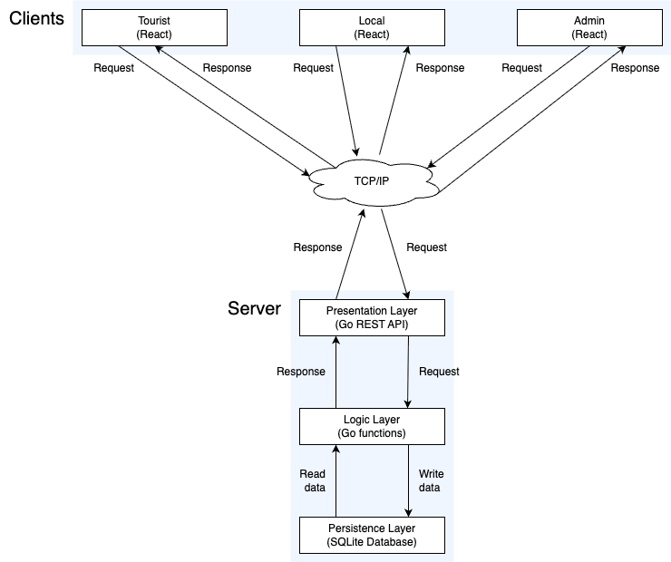
3.3. Software Architecture Initial Plan – Layered Client-Server
January 26
Justification:
- Layered server architecture allows a basic solution on a layer for the MVP, like SQLite or the limited API, to be swapped for a more robust solution with little refactoring in the other layers
- Client-server allows for place data to be served from a ‘single source of truth’ database without duplication. It also ensures data security by acting as a middleman checking account permissions
- Client-server allows for easy scaling of both users and backend resources independently

3.4. Sprint 1
January 28
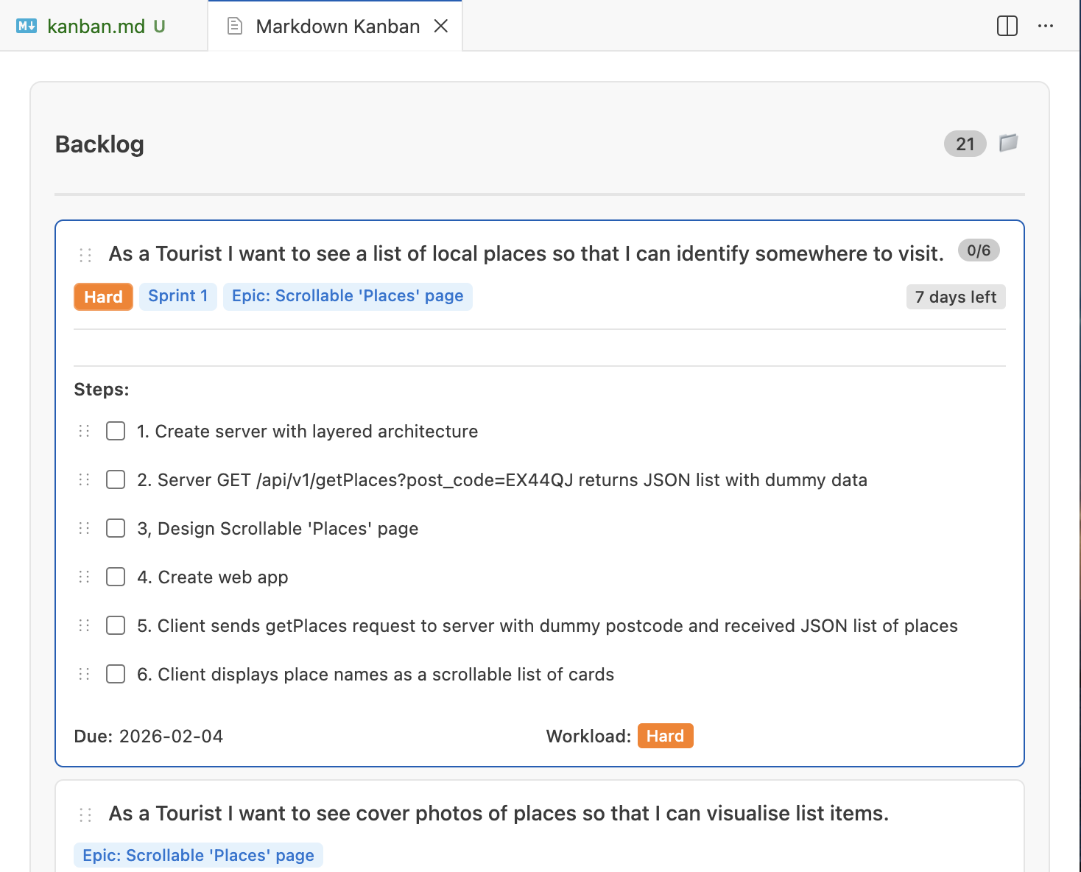
Sprint 1 Planning
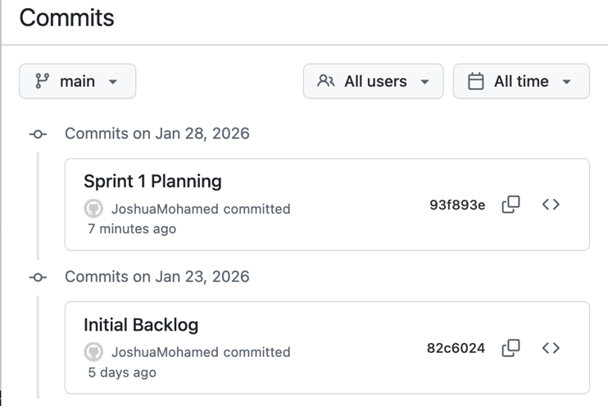

February 2
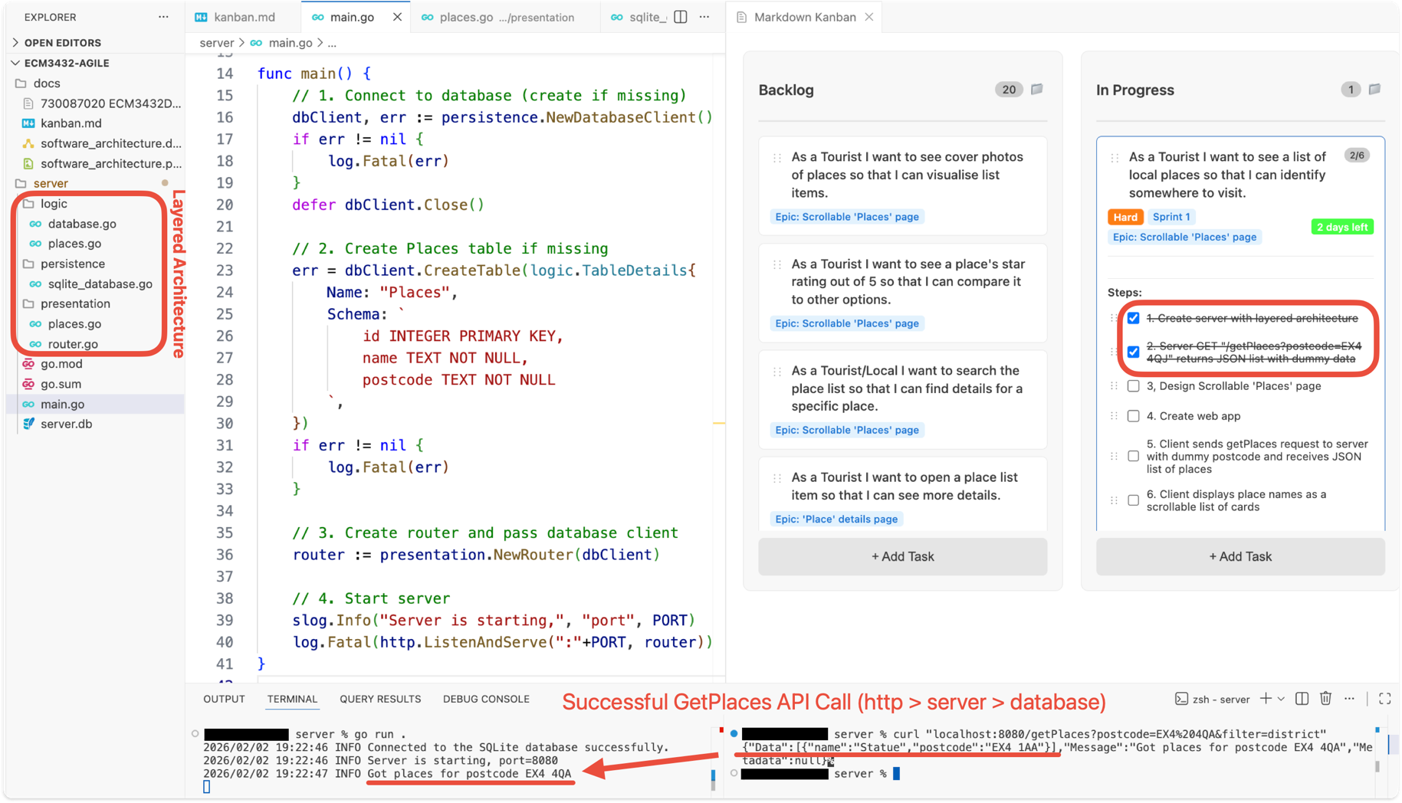
Sprint 1: Create server with layered architecture & Get Places API
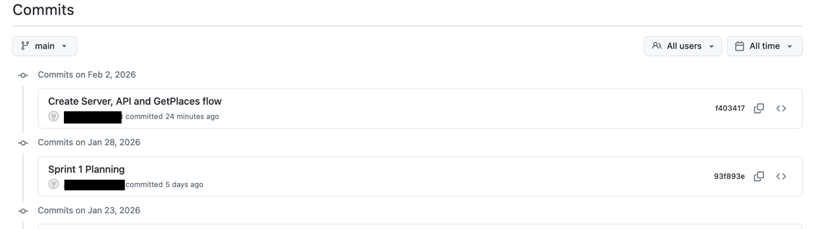
February 9
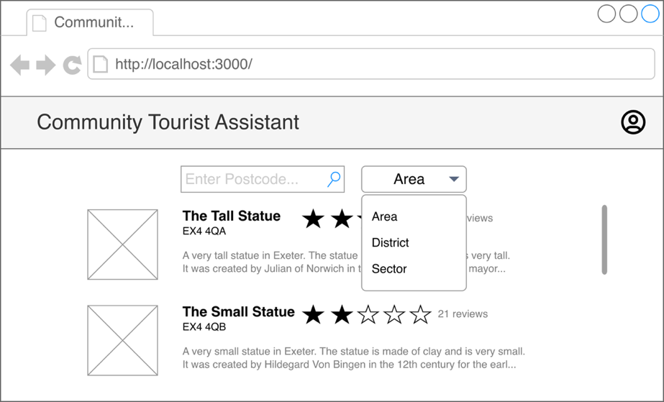
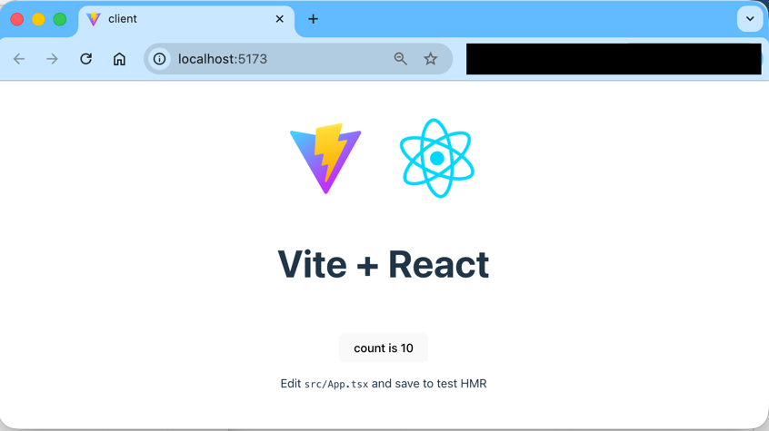
Sprint 1: Create initial UI design, web app (AI assisted) & Places page
(DIAGRAM)
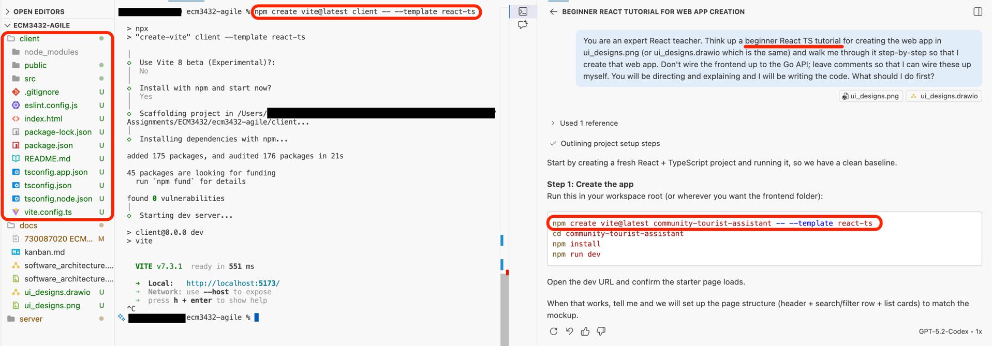
2
3
1

February 11
Sprint 1 Review
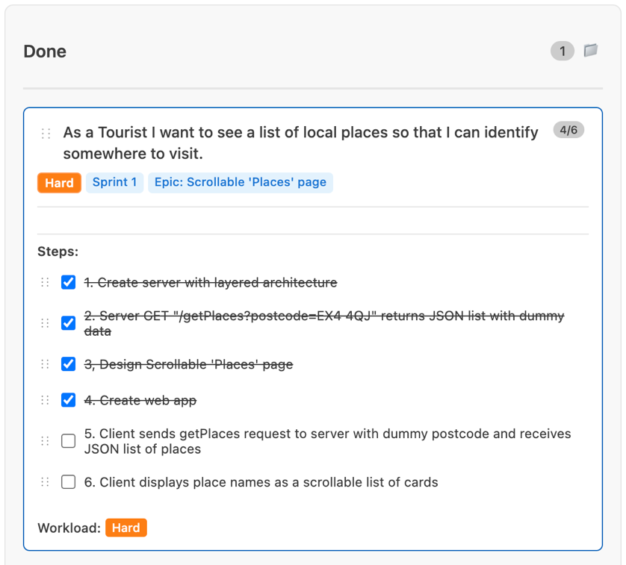
Good:
- I made a significant start to development
- I created the layered server backend and Get Places API
- I designed and kickstarted the frontend
Bad:
- I did not complete the whole user story
- This was foreseeable; I should have broken the ‘hard’ story into smaller stories
- I should have written server unit tests before starting the frontend
Action:
- I will roll over the unit tests and ‘Places’ frontend to Sprint 2
- I will only take on smaller stories, breaking down ‘Hard’ stories

3.5. Sprint 2
February 11
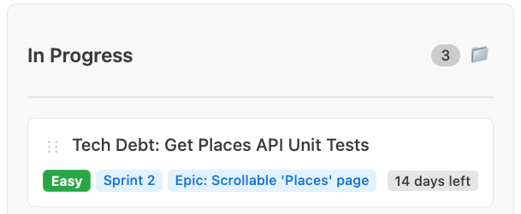
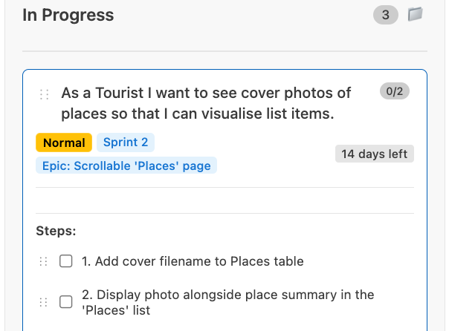
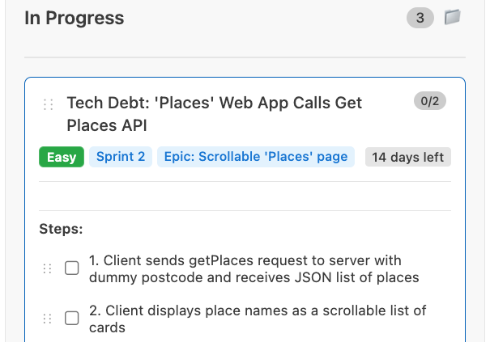
Sprint 2 Planning

February 11
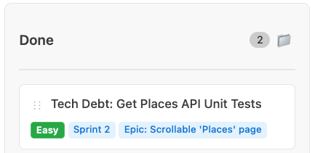
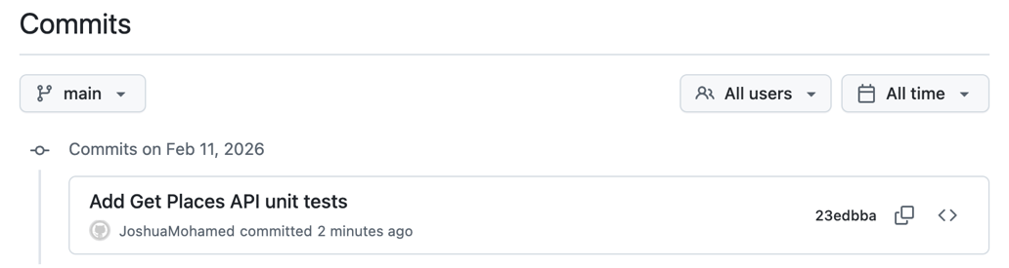
Sprint 2: Create ‘Places’ frontend & display cover photos
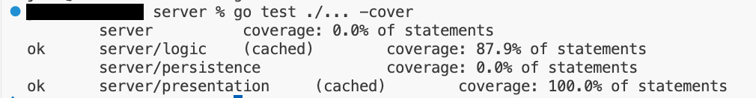
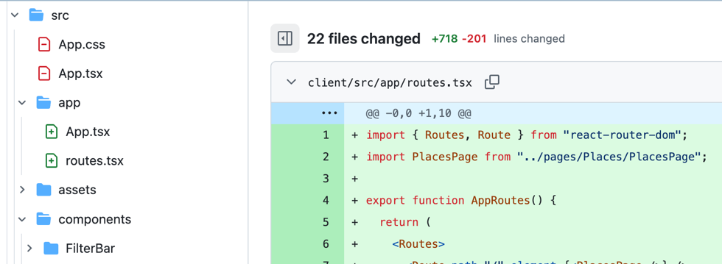
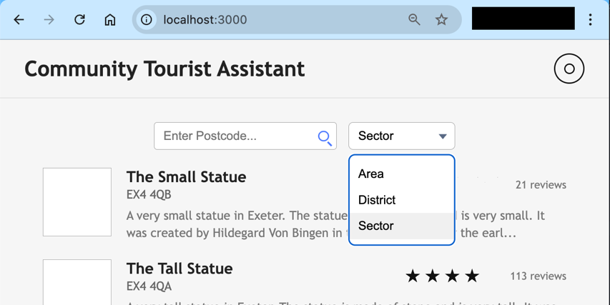

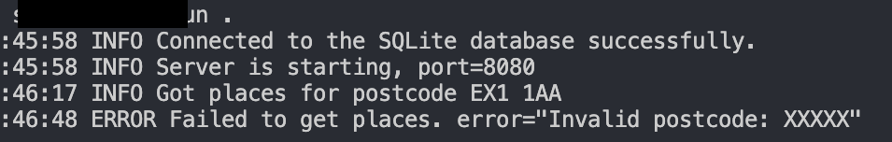
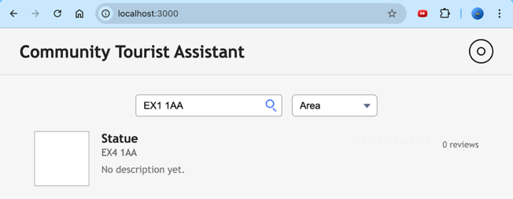
Sprint 2: Wire the frontend to the backend to get real data

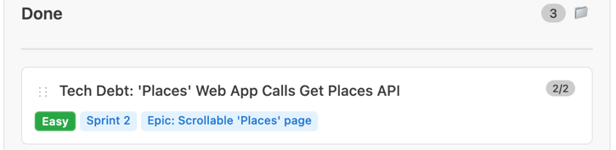
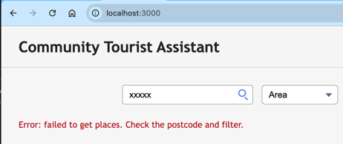

Appendix
Git, 2026. git. [Online]
Available at: https://git-scm.com/
[Accessed January 2026].
Github, 2025. Markdown Kanban. [Online]
Available at: https://github.com/holooooo/markdown-kanban
[Accessed January 2026].
Ozkan, N., Bal, S., Erdogan, T. G. & Gök, M. Ş., 2022. Scrum, Kanban or a Mix of Both? A Systematic Literature Review. [Online]
Available at: https://ieeexplore.ieee.org/abstract/document/9909164
[Accessed January 2026].
Tunggal, A. T., 2026. Bitbucket vs GitHub (Updated for 2026). [Online]
Available at: https://www.upguard.com/blog/bitbucket-vs-github
[Accessed January 2026].

